Unit 2: Entity-Relationship Model (ER Model)

Entity in DBMS
An entity in DBMS represents a real-world object or concept that can be uniquely identified and stored in a database. It forms the foundation of data modelling in an Entity-Relationship (ER) model.
Example: A student, an employee, or bank a/c, etc. all are entities.
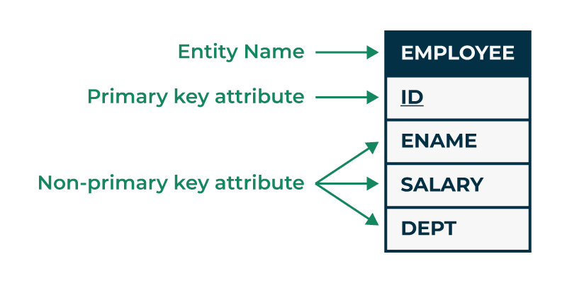

Kinds of Entities
There are two types of Entities:
1. Tangible Entity
A tangible entity is a physical object or a physical thing that can be physically touched, seen or measured. It has a physical existence or can be seen directly.
Now lets understand this with the help of example:
Examples of Tangible entities are real, physical things like products (e.g., inventory items) or people (e.g., customers and employees).
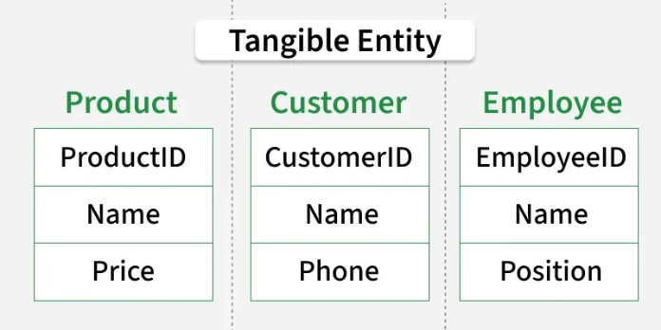

2. Intangible Entity
Intangible entities are abstract or conceptual objects that are not physically present but have meaning in the database. They are typically defined by attributes or properties that are not directly visible.
Now lets understand this with the help of example:
Examples of Intangible entities are non-physical things like concepts (e.g., product categories, service types) or events (e.g., appointments, transactions).
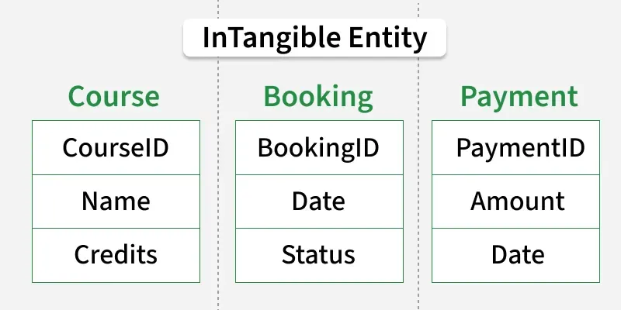

Entity Types in DBMS
There are two types of Entity:
1. Strong Entity Types: These are entities that exist independently and have a completely unique identifier.
- A strong entity is not dependent on any other entity in the schema.
- A strong entity will always have a primary key.
- Strong entities are represented by a single rectangle.
- The relationship of two strong entities is represented by a single diamond.
- Various strong entities, when combined together, create a strong entity set.
2. Weak Entity Types: These entities depend on another entity for his or her lifestyles and do now not have a completely unique identifier on their own.
- A weak entity is dependent on a strong entity to ensure its existence.
- Unlike a strong entity, a weak entity does not have any primary key.
- It instead has a partial discriminator key which is an attribute that helps uniquely identify weak entities.
- A weak entity is represented by a double rectangle.
- The relation between one strong and one weak entity is represented by a double diamond.
- This relationship is also known as an identifying relationship.

Example of Strong and Weak Entity Types in DMBS is:
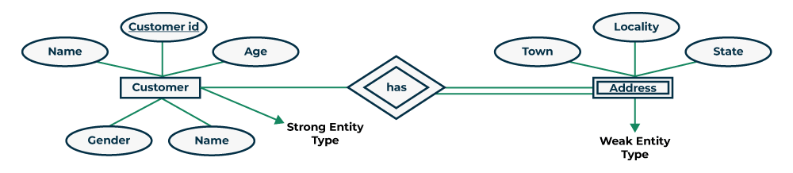

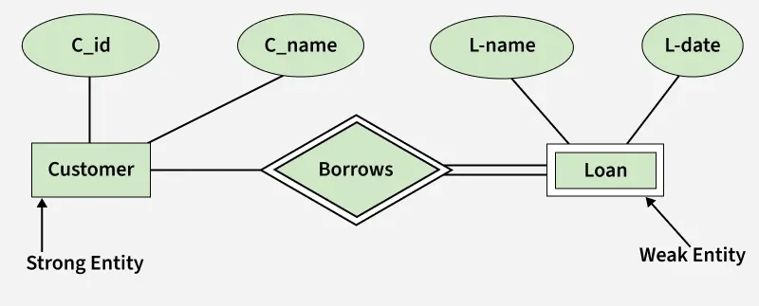
In ER models, strong entities can exist independently, whereas weak entities depend on strong entities.
In ER diagrams, single and double lines around a relationship or entity have special meanings related to participation and weak entities.
1️⃣ Single line between entity and relationship
A single line means partial participation.
- Not every entity instance must participate in the relationship.
- Participation is optional.
Example:
If Customer — borrows — Loan had a single line from Customer, it would mean:
Some customers may not take any loan.

2️⃣ Double line between entity and relationship
A double line means total participation.
- Every entity instance must participate in that relationship.
- Participation is mandatory.
In diagram:
The weak entity (like Loan or Address) is connected with a double line to the relationship.
This means:
- A weak entity cannot exist without the strong entity.
- Example: A loan cannot exist without a customer → so total participation.

3️⃣ Double diamond (relationship symbol)
The relationship like “Borrows” or “Has” is shown with a double diamond.
This indicates an identifying relationship for a weak entity.
Meaning:
- Weak entity depends on strong entity.
- Its primary key is formed using the strong entity’s key.

🔑 Summary (very important for exams)
Symbol | Meaning
Single line | Partial participation (optional)
Double line | Total participation (mandatory)
Double diamond | Identifying relationship for weak entity
Double rectangle | Weak entity

In diagram specifically
- Customer → Borrows : single line → customer may or may not borrow
- Loan → Borrows : double line → loan must belong to a customer
- Double diamond → identifying relationship
- Loan → weak entity dependent on customer

Difference Between Strong and Weak Entity
Strong Entity | Weak Entity
Strong entity always has a primary key. | While a weak entity has a partial discriminator key.
Strong entity is not dependent on any other entity. | Weak entity depends on strong entity.
Strong entity is represented by a single rectangle. | Weak entity is represented by a double rectangle.
Two strong entity's relationship is represented by a single diamond. | While the relation between one strong and one weak entity is represented by a double diamond.

Entity Sets

